Exercise #01
Student Registration Form
Android Developer Bootcamp

🎯Purpose
Create a simple registration form using TextView, EditText, and Button.
🧩 Problem
Design a screen that contains:
- A title TextView: "Student Registration"
- EditText for:
  - Student Name
  - Roll Number
  - Email Address
- A Button labeled "Register"
- Proper spacing between all components.
- The layout should be centered and look organized.

How to Solve
- Create a new Android project.
- Add a TextView as the title with the text "Enter Your Name".
- Add an EditText for entering the user's name.
- Add another TextView as a label for the input field.
- Add a Button with the text "Submit".
- Arrange all views vertically using a LinearLayout.
- Apply appropriate padding and margins to improve the UI appearance.
- Set suitable hints, text sizes, and widths for the components.
- Run the application and verify that the layout is displayed correctly.

You Will Achieve
- TextView – Used to display headings, labels, and other text content on the screen.
- EditText – Used to collect user input through text fields.
- Button – Used to create clickable action controls in the user interface.
- LinearLayout – Used to arrange views vertically in a structured manner.
- Margin and Padding – Used to provide proper spacing between views and within layouts.
- Layout Attributes – Understanding the use of layout_width, layout_height, orientation, text, hint, and gravity.
- UI Design Principles – Creating a clean and organized form layout using XML components.
- View Properties – Applying text size, text style, and spacing attributes to improve the appearance of the interface.

Screenshots
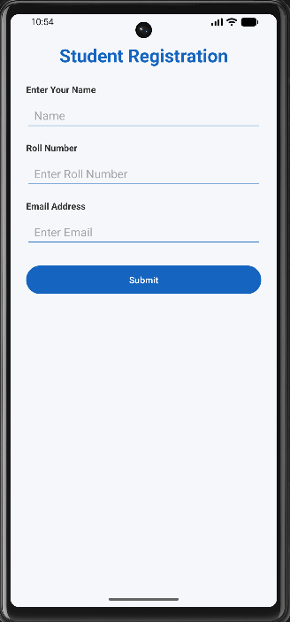

How to upload
git add .
git commit -m "Completed exercise"
git push origin <your-branch-name>

